

Rental Management Office
115 South Quarry St.
Ithaca, NY 14850 USA

Phone: 607-277-1234
Fax: 607-277-7038
www.ithacastudentapartments.com

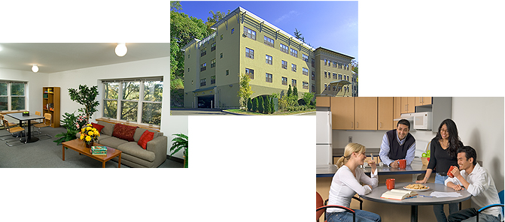

Novarr-Mackesey Property Management offers the best apartments in Ithaca, NY near Cornell University. We have provided great student rentals to Cornell students for over 25 years. We have a friendly staff of dedicated professionals with over 40 years of combined experience who work hard to take care of all of your housing needs. We offer full-time office and maintenance staff with 24-hour emergency answering service.
Our student apartments and tenants reflect the diversity of the Cornell community. We are proud of our many Ithaca rental apartments and houses. They range from traditional Arts and Crafts houses to new, luxury apartments. We provide high-quality, modern furnishings and many great amenities, such as on-site laundry, high-speed Internet access, free fitness center, free parking and a free daily shuttle to the Cornell campus. See our variety of rental housing options, one of which is sure to suit your particular needs.
For more information, contact:
Novarr-Mackesey Property Management
115 South Quarry Street
Ithaca, NY 14850
USA
Phone: 607-277-1234
Fax: 607-277-7038
Email: info@ithacastudentapartments.com

Table of Contents

Apartment Listing by Type 4
Apartment Listing by Property 6
Boiler Works Apartments 8
Casa Roma Apartments 9
College Park Apartments 10
Fall Creek Apartments 11
Quarry Properties 12
Sage Apartments 13
Valentine Park Apartments 14
Valentine Apartments (113-115 Valentine Place) 15
Valentine Apartments (120 Valentine Place) 16
120 Oak Avenue (Apartments) 17
504 ½ Thurston Ave 18
809-811 East State Street 19
817 East State Street 20
103 Sage Place 21
112 Valentine Place 22
119 The Knoll 23
120 Oak Avenue (House for Rent) 24
201 Wyckoff Avenue 25
504 Thurston Ave 26
505 East Seneca Street 27
903 East State Street 28
909 East State Street 29
911 East State Street 30

Apartment Listing by Type

At Novarr-Mackesey Property Management, we are proud to present high-quality student rentals for varying budgets. We offer a large selection of rental options for Cornell students, from individual rooms to whole houses. Our properties range from new construction of high-quality modern spaces to recent renovations of traditional houses.

For more information including floor plans and photos, go to www.ithacastudentapartments.com
For price and availability, contact us now at 607-277-1234 or info@ithacastudentapartments.com

Private Rooms
- Quarry Properties – 115 South Quarry Street

Studios
- Casa Roma Apartments – 111 South Quarry Street
- Boiler Works Apartments – 123 South Quarry Street
- Valentine Apartments – 113-115 Valentine Place
- Valentine Apartments – 120 Valentine Place
- Quarry Properties – 115 South Quarry Street
- 504 ½ Thurston Avenue
- 809-811 East State Street

1-Bedroom Apartments
- Casa Roma Apartments – 111 South Quarry Street
- Boiler Works Apartments – 123 South Quarry Street
- Valentine Apartments – 113-115 Valentine Place
- Valentine Apartments – 120 Valentine Place
- Quarry Properties – 115 South Quarry Street
- 120 Oak Avenue
- 809-811 East State Street
- 817 East State Street

2-Bedroom Apartments
- Casa Roma Apartments – 111 South Quarry Street
- Valentine Park Apartments – 122-154 Valentine Place
- Valentine Apartments – 113-115 Valentine Place
- Valentine Apartments – 120 Valentine Place
- College Park Apartments – 905-907 East State Street
- 120 Oak Avenue
- Sage Apartments – 109 Sage Place
- 809-811 East State Street

2-Bedrooms + Loft
- Sage Apartments – 109 Sage Place

3-Bedroom Apartments
- Casa Roma Apartments – 111 South Quarry Street
- Valentine Apartments – 113-115 Valentine Place
- Valentine Park Apartments – 122-154 Valentine Place
- College Park Apartments – 905-907 East State Street
- Fall Creek Apartments – 207-215 Fall Creek Drive
- Sage Apartments – 109 Sage Place
- 809-811 East State Street
- 817 East State Street

3-Bedrooms + Loft
- Valentine Park Apartments – 122-154 Valentine Place
- Sage Apartments – 109 Sage Place

4-Bedroom Apartments
- Valentine Apartments – 120 Valentine Place
- Valentine Park Apartments – 122-154 Valentine Place

4-Bedrooms + Loft
- Valentine Park Apartments – 122-154 Valentine Place

5-Bedroom Apartments
- Valentine Park Apartments – 122-154 Valentine Place

6-Bedroom Apartments
- 817 East State Street

6-Bedrooms + Loft
- Valentine Park Apartments – 122-154 Valentine Place

Houses for Rent

120 Oak Avenue | 10-Bedroom House
505 East Seneca Street | 7-Bedroom House
103 Sage Place | 7-Bedroom House
903 East State Street | 6-Bedroom House
909 East State Street | 12-Bedroom House
911 East State Street | 5-Bedroom House
112 Valentine Place | 5-Bedroom House
201 Wyckoff Avenue | 6-Bedroom House
504 Thurston Avenue | 6-Bedroom House
119 The Knoll | 10-Bedroom House

Apartment Listing by Property

Casa Roma Apartments
111 South Quarry Street
Studios, 1, 2, and 3-bedroom apartments

Boiler Works Apartments
123 South Quarry Street
Studios and 1-bedroom apartments

Valentine Apartments
113-115 Valentine Place
Studios, 1, 2, and 3-bedroom apartments

Valentine Apartments
120 Valentine Place
Studios, 1, 2, and 4-bedroom apartments

Valentine Park Apartments
122-154 Valentine Place
2, 3, 4 and 5-bedroom apartments
3-bedrooms + loft
4-bedrooms + loft
6 bedrooms + loft

College Park Apartments
905-907 East State Street
2 and 3-bedroom apartments

Quarry Properties
115 South Quarry Street
Private rooms, studios and 1-bedroom apartments

Fall Creek Apartments
207-215 Fall Creek Drive
3-bedroom apartments

Sage Apartments
109 Sage Place
2 and 3-bedroom apartments
2-bedrooms + loft
3-bedrooms + loft

120 Oak Avenue
1 and 2-bedroom apartments

809-811 East State Street
Studios, 1, 2 and 3-bedroom apartments

817 East State Street
1, 3 and 6-bedroom apartments

504 ½ Thurston Avenue
Studio apartment

120 Oak Avenue | 10-Bedroom House
505 East Seneca Street | 7-Bedroom House
103 Sage Place | 7-Bedroom House
903 East State Street | 6-Bedroom House
909 East State Street | 12-Bedroom House
911 East State Street | 5-Bedroom House
112 Valentine Place | 5-Bedroom House
201 Wyckoff Avenue | 6-Bedroom House
504 Thurston Avenue | 6-Bedroom House
119 The Knoll | 10-Bedroom House

Boiler Works Apartments

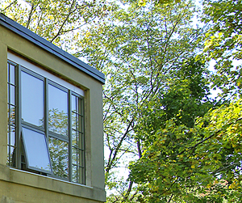

Studios and 1-bedroom apartments

123 South Quarry Street
Ithaca, NY 14850
These new and stunning luxury apartments are positioned on the edge of Six Mile Creek Gorge, taking advantage of the incredible view. Some units have walls of windows overlooking the gorge.
- Contemporary architecture
- Fully furnished
- Price includes heat & hot water
- Limestone entry, kitchen and bathroom floors
- Stainless steel kitchen counter tops
- Dishwasher, microwave, garbage disposal
- Secured entry system
- Monitored heat detection system
- Smoke detectors
- Sprinkler system
- On-site coin-op laundry
- High-speed Internet access available
- Access to free fitness center
- Access to TV lounge
- Free parking
- Free shuttle to Cornell
- On city bus route
The free shuttle runs every 20 minutes from 7:30am until 11:30am weekdays throughout the academic year.
This building location is a 10-15 minute walk to Cornell approximately. See map online.
For more information including floor plans and photos, go to www.ithacastudentapartments.com
For price and availability, contact us now at 607-277-1234 or info@ithacastudentapartments.com

Casa Roma Apartments

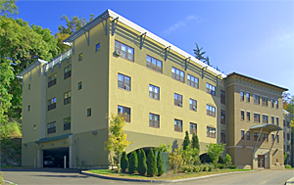

Studios, 1, 2 and 3-bedroom apartments

111 South Quarry Street
Ithaca, NY 14850
- New luxury apartments
- Contemporary architecture
- Beautifully landscaped area near gorge
- Fully furnished
- Price includes heat & hot water
- 3-bedroom units have 2 full bathrooms
- Limestone kitchen & bathroom floors
- Stainless steel kitchen and bathroom countertops
- Microwave, garbage disposal
- Secured entry system
- Monitored heat detection system
- Smoke detectors
- Sprinkler system
- On-site coin-op laundry
- Free high-speed Internet
- Free on-site fitness center
- Free on-site TV/media room
- Free undercover parking
- Free shuttle to Cornell
- On city bus route
The free shuttle runs every 20 minutes from 7:30am until 11:30am weekdays throughout the academic year.
This building location is a 10-15 minute walk to Cornell campus. See map online.
For more information including floor plans and photos, go to www.ithacastudentapartments.com
For price and availability, contact us now at 607-277-1234 or info@ithacastudentapartments.com

College Park Apartments

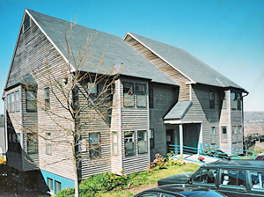

2 and 3-bedroom apartments

905-907 East State Street
Ithaca, NY 14850
- Modern architecture
- Nicely landscaped area near gorge
- Fully furnished
- Wall-to-wall carpeting
- Energy-efficient thermal storage heaters
- Smoke detectors
- On-site coin-op laundry
- High-speed Internet access available
- Access to free fitness center
- Access to TV lounge
- Free parking
- Free shuttle to Cornell
- On city bus route
The free shuttle runs every 20 minutes from 7:30am until 11:30am weekdays throughout the academic year.
This building location is an approximate 10-minute walk to Cornell. See map online.
For more information including floor plans and photos, go to www.ithacastudentapartments.com
For price and availability, contact us now at 607-277-1234 or info@ithacastudentapartments.com

Fall Creek Apartments

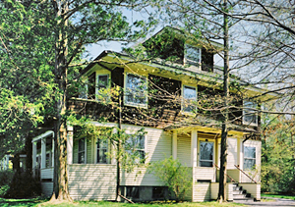

3-bedroom apartments

207-215 Fall Creek Drive
Ithaca, NY 14850
This building is on the edge of Cornell North Campus, next to the suspension bridge. It takes just seconds to walk to campus! See map online.
- Turn-of-the-century shingle style architecture
- Beautiful wooded area on Fall Creek gorge
- Architecturally distinctive interiors
- Spacious, open floor-plans with large bedrooms
- Fully furnished
- Wall-to-wall carpeting
- Full basement
- Smoke & carbon monoxide detectors
- Sprinkler system
- Energy-efficient thermal storage heaters
- On-site coin-op laundry
- High-speed Internet access available
- Access to free fitness center
- Free parking
For more information including floor plans and photos, go to www.ithacastudentapartments.com
For price and availability, contact us now at 607-277-1234 or info@ithacastudentapartments.com

Quarry Properties

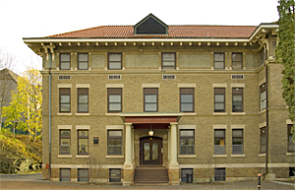

Private rooms, studios and 1-bedroom apartments

115 South Quarry Street
Ithaca, NY 14850
- Traditional Arts & Craft style architecture
- Beautiful wooded area near gorge
- Price includes all utilities
- Private rooms available with no bath, half-bath, or full-baths.
- Fully furnished
- Wall-to-wall carpeting
- Shared kitchen facilities
- Small refrigerator in each room
- Monitored heat detection system
- Smoke detectors
- Sprinkler system
- On-site coin-op laundry
- High-speed Internet access available
- Free on-site fitness center
- Two TV lounges
- Pool table room
- Free parking
- Free shuttle to Cornell
- On city bus route
The free shuttle runs every 20 minutes from 7:30am until 11:30am weekdays throughout the academic year.
This building location is an approximate 10-15 minute walk to Cornell. See map online.

For more information including floor plans and photos, go to www.ithacastudentapartments.com
For price and availability, contact us now at 607-277-1234 or info@ithacastudentapartments.com

Sage Apartments

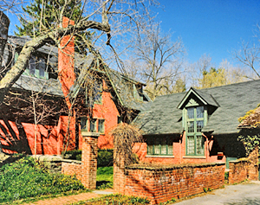

2 and 3-bedroom apartments
2-bedrooms + loft
3-bedrooms + loft

109 Sage Place
Ithaca, NY 14850
- Traditional and unique architecture
- Beautiful perennial garden
- Units with loft have spiral staircase & skylight
- Fully furnished
- Kitchen with built-in microwave
- Monitored heat detection system
- Smoke & carbon monoxide detectors
- On-site coin-op laundry
- High-speed Internet access available
- Access to free fitness center
- On city bus route
This building location is an approximate 15-minute walk to Cornell. See map online.

For more information including floor plans and photos, go to www.ithacastudentapartments.com
For price and availability, contact us now at 607-277-1234 or info@ithacastudentapartments.com

Valentine Park Apartments

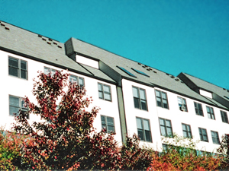

2, 3, 4, and 5-bedrooms apartments
3-bedrooms + loft
4-bedrooms + loft
6-bedrooms + loft

122-154 Valentine Place
Ithaca, NY 14850
- Modern architecture
- Large, bright and spacious
- Units with loft have cathedral ceiling & skylight
- 6-bedroom + loft apartments have 2 full baths
- Beautiful wooded area near gorge
- Fully furnished
- Wall-to-wall carpeting
- Newly renovated kitchens with stainless steel countertops
- Dishwashers
- Energy-efficient thermal storage heaters
- Smoke detectors
- On-site coin-op laundry
- Free high-speed Internet access
- Access to free fitness center
- Access to TV lounge
- Free parking
- Free shuttle to Cornell
- On city bus route
The free shuttle runs every 20 minutes from 7:30am until 11:30am weekdays throughout the academic year.
This building location is an approximate 10-minute walk to Cornell.

For more information including floor plans and photos, go to www.ithacastudentapartments.com
For price and availability, contact us now at 607-277-1234 or info@ithacastudentapartments.com

Valentine Apartments (113-115 Valentine Place)

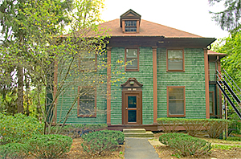

Studios, 1, 2, and 3-bedroom apartments

113-115 Valentine Place
Ithaca, NY 14850
- Traditional architecture
- Some apartment prices include heat & electric
- Fully furnished
- Wall-to-wall carpeting
- Most with stainless steel kitchen countertops
- Secured entry system
- Monitored heat detection system
- Some apartments have carbon monoxide detectors
- On-site coin-op laundry
- High-speed Internet access available
- Access to free fitness center
- TV lounge
- Free parking
- Free shuttle to Cornell
- On city bus route
The free shuttle runs every 20 minutes from 7:30am until 11:30am weekdays throughout the academic year.
This building location is an approximate 10-minute walk to Cornell. See map online.

For more information including floor plans and photos, go to www.ithacastudentapartments.com
For price and availability, contact us now at 607-277-1234 or info@ithacastudentapartments.com

Valentine Apartments (120 Valentine Place)

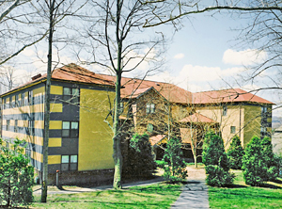

Studios, 1, 2, and 4-bedroom apartments

120 Valentine Place
Ithaca, NY 14850
- Modern and unique architecture
- Beautiful wooded area near gorge
- Fully furnished
- Wall-to-wall carpeting
- Secured entry system
- Monitored heat detection system
- Smoke detectors
- Sprinkler system
- On-site coin-op laundry
- High-speed Internet access available
- Access to free fitness center
- Access to TV lounge
- Free parking
- Free shuttle to Cornell
- On city bus route
The free shuttle runs every 20 minutes from 7:30am until 11:30am weekdays throughout the academic year.
This building location is an approximate 10-minute walk to Cornell. See map online.

For more information including floor plans and photos, go to www.ithacastudentapartments.com
For price and availability, contact us now at 607-277-1234 or info@ithacastudentapartments.com

120 Oak Avenue (Apartments)

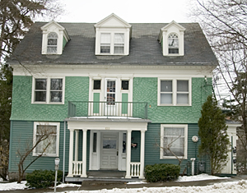

1-bedroom apartment
2-bedroom apartment

120 Oak Avenue
Ithaca, NY 14850
This building location is on the edge of the Cornell campus. It takes just seconds to walk to campus and is in the heart of Collegetown! See map online.
- Traditional architecture
- Beautiful wooded area near Cascadilla gorge
- Fully furnished
- Wall-to-wall carpeting
- Full kitchen with built-in microwave
- Gas heat
- Monitored heat detection system
- Smoke & carbon monoxide detectors
- Sprinkler system
- High-speed Internet access available
- Access to free fitness center
- On city bus route
For more information including floor plans and photos, go to www.ithacastudentapartments.com
For price and availability, contact us now at 607-277-1234 or info@ithacastudentapartments.com

504 ½ Thurston Ave

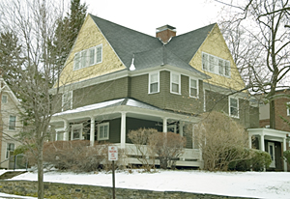

Studio

504 ½ Thurston Avenue
Ithaca, NY 14850
This building location is right on Cornell North Campus, directly across from the tennis courts.
See map online.
- Traditional architecture
- Fully furnished
- Full bath
- All electric appliances
- Private entrance
- Access to coin-op laundry
- High-speed Internet access available
- Access to free fitness center
For more information including floor plans and photos, go to www.ithacastudentapartments.com
For price and availability, contact us now at 607-277-1234 or info@ithacastudentapartments.com

809-811 East State Street

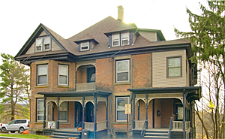

Studios, 1, 2 and 3-bedroom apartments

809-811 East State Street
Ithaca, NY 14850
- Traditional architecture
- Most apartment prices include heat & electric
- Fully furnished
- Carpeting and hardwood flooring
- Monitored heat detection system
- Smoke & carbon monoxide detectors
- On-site coin-op laundry
- High-speed Internet access available
- Access to free fitness center
- Access to TV lounge
- Off-street parking
- Free shuttle to Cornell
- On city bus route
The free shuttle runs every 20 minutes from 7:30am until 11:30am weekdays throughout the academic year.
This building location is an approximate 10-minute walk to Cornell. See map online.

For more information including floor plans and photos, go to www.ithacastudentapartments.com
For price and availability, contact us now at 607-277-1234 or info@ithacastudentapartments.com

817 East State Street

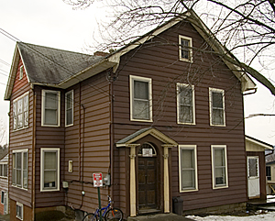

1, 3 and 6-bedroom apartments

817 East State Street
Ithaca, NY 14850
- Traditional architecture
- Fully furnished
- Carpeting and hardwood flooring
- Monitored heat detection system
- Smoke & carbon monoxide detectors
- On-site coin-op laundry
- High-speed Internet access available
- Access to free fitness center
- Access to TV lounge
- Off-street parking
- Free shuttle to Cornell
- On city bus route
The free shuttle runs every 20 minutes from 7:30am until 11:30am weekdays throughout the academic year.
This building location is an approximate 10-minute walk to Cornell. See map online.

For more information including floor plans and photos, go to www.ithacastudentapartments.com
For price and availability, contact us now at 607-277-1234 or info@ithacastudentapartments.com

103 Sage Place

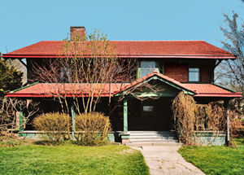

7-bedroom house

103 Sage Place
Ithaca, NY 14850
- Maximum occupancy of 9 people
- 4 full baths
- Historic house with many architectural features
- Beautiful perennial garden
- Spacious bedrooms
- Beautifully furnished
- Large living room with fireplace
- Formal dining room
- Hardwood flooring
- Built-in bookshelves
- Large front porch
- Full basement
- Monitored heat detection system
- Smoke & carbon monoxide detectors
- On-site coin-op laundry
- High-speed Internet access available
- Access to free fitness center
- Private driveway & garage
- On city bus route
This building location is an approximate 15-minute walk to Cornell. See map online.

For more information including floor plans and photos, go to www.ithacastudentapartments.com
For price and availability, contact us now at 607-277-1234 or info@ithacastudentapartments.com

112 Valentine Place

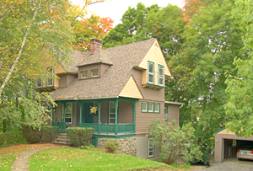

5-bedroom house

112 Valentine Place
Ithaca, NY 14850
- Maximum occupancy of 5 people
- 2 full baths
- Traditional architecture
- Large front porch
- Hardwood flooring
- Fully furnished
- Built-in bookshelves
- Dishwasher, microwave, garbage disposal
- Smoke & carbon monoxide detectors
- Access to coin-op laundry
- High-speed Internet access available
- Access to free fitness center
- Access to TV lounge
- Private driveway and garage
- Free shuttle to Cornell
- On city bus route
The free shuttle runs every 20 minutes from 7:30am until 11:30am weekdays throughout the academic year.
This building location is an approximate 10-minute walk to Cornell. See map online.

For more information including floor plans and photos, go to www.ithacastudentapartments.com
For price and availability, contact us now at 607-277-1234 or info@ithacastudentapartments.com

119 The Knoll

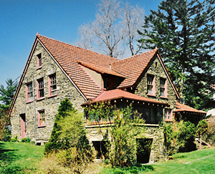

10-bedroom house

119 The Knoll
Ithaca, NY 14850
This building location is right on Cornell North Campus, near the suspension bridge. See map online.
- Maximum occupancy of 14 people
- 3 full baths
- 2 full kitchens
- Large, secluded natural setting with great view of Ithaca
- Traditional architecture
- Gorgeous stone mansion
- Private driveway & garage
- Hardwood flooring
- Living room with fireplace
- Fully furnished
- Smoke & carbon monoxide detectors
- On-site coin-op laundry
- High-speed Internet access available
- Access to free fitness center
For more information including floor plans and photos, go to www.ithacastudentapartments.com
For price and availability, contact us now at 607-277-1234 or info@ithacastudentapartments.com

120 Oak Avenue (House for Rent)

10-bedroom house

120 Oak Avenue
Ithaca, NY 14850
This building location is on the edge of the Cornell campus. It takes just seconds to walk to campus and is in the heart of Collegetown! See map online.
- Maximum occupancy of 10 people
- 2 ½ baths
- Traditional architecture
- Beautiful wooded area near Cascadilla gorge
- Fully furnished
- Wall-to-wall carpeting
- Full kitchen with built-in microwave
- Gas heat
- Monitored heat detection system
- Smoke & carbon monoxide detectors
- Sprinkler system
- High-speed Internet access available
- Access to free fitness center
- On city bus route
For more information including floor plans and photos, go to www.ithacastudentapartments.com
For price and availability, contact us now at 607-277-1234 or info@ithacastudentapartments.com

201 Wyckoff Avenue

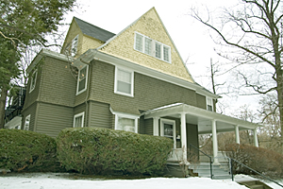

6-bedroom house

201 Wyckoff Avenue
Ithaca, NY 14850
This building location is right on Cornell North Campus, directly across from the tennis courts.
See map online.
- Maximum occupancy of 6 people
- 2 full baths
- Traditional architecture
- Large front porch
- Spacious bedrooms
- Hardwood flooring
- Fully furnished
- Full basement
- Monitored heat detection system
- Smoke & carbon monoxide detectors
- On-site coin-op laundry
- High-speed Internet access available
- Access to free fitness center
For more information including floor plans and photos, go to www.ithacastudentapartments.com
For price and availability, contact us now at 607-277-1234 or info@ithacastudentapartments.com

504 Thurston Ave

6-bedroom house

504 Thurston Avenue
Ithaca, NY 14850
This building location is right on Cornell North Campus, directly across from the tennis courts.
See map online.
- Maximum occupancy of 6 people
- 2 full baths
- Traditional architecture
- Spacious bedrooms
- Fully furnished
- Full basement
- Monitored heat detection system
- Smoke & carbon monoxide detectors
- On-site coin-op laundry
- High-speed Internet access available
- Access to free fitness center
For more information including floor plans and photos, go to www.ithacastudentapartments.com
For price and availability, contact us now at 607-277-1234 or info@ithacastudentapartments.com

505 East Seneca Street

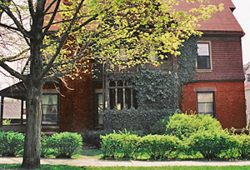

7-bedroom house

505 East Seneca Street
Ithaca, NY 14850
- Maximum occupancy of 8 people
- 3 ½ baths
- Gorgeous, gothic style house
- Enormous bedrooms
- Large wrap-around porch
- Fully furnished
- Dishwasher, microwave, 2 refrigerators
- Full basement
- Monitored heat detection system
- Smoke & carbon monoxide detectors
- On-site coin-op laundry
- High-speed Internet access available
- Access to free fitness center
- Private driveway & large garage
- On city bus route
For more information including floor plans and photos, go to www.ithacastudentapartments.com
For price and availability, contact us now at 607-277-1234 or info@ithacastudentapartments.com

903 East State Street

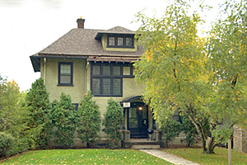

6-bedroom house

903 East State Street
Ithaca, NY 14850
- Maximum occupancy of 6 people
- 2 full baths
- Traditional architecture
- Spacious bedrooms
- Hardwood flooring
- Fully furnished
- Full basement
- Monitored heat detection system
- Smoke & carbon monoxide detectors
- Access to coin-op laundry
- High-speed Internet access available
- Access to free fitness center
- Access to TV lounge
- Private driveway & garage
- Free shuttle to Cornell
- On city bus route
The free shuttle runs every 20 minutes from 7:30am until 11:30am weekdays throughout the academic year.
This building location is an approximate 10-minute walk to Cornell. See map online.

For more information including floor plans and photos, go to www.ithacastudentapartments.com
For price and availability, contact us now at 607-277-1234 or info@ithacastudentapartments.com

909 East State Street

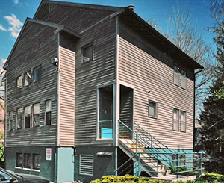

12-bedroom house

909 East State Street
Ithaca, NY 14850
- Maximum occupancy of 12 people
- 3 full baths
- Contemporary architecture
- Bright and spacious
- Fully furnished
- Energy efficient
- Smoke & carbon monoxide detectors
- On-site coin-op laundry
- High-speed Internet access available
- Access to free fitness center
- Access to TV lounge
- Free parking
- Free shuttle to Cornell
- On city bus route
The free shuttle runs every 20 minutes from 7:30am until 11:30am weekdays throughout the academic year.
This building location is an approximate 10-minute walk to Cornell. See map online.

For more information including floor plans and photos, go to www.ithacastudentapartments.com
For price and availability, contact us now at 607-277-1234 or info@ithacastudentapartments.com

911 East State Street

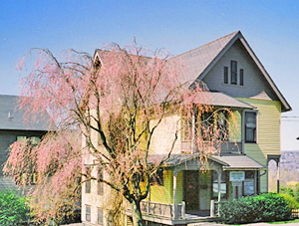

5-bedroom house

911 East State Street
Ithaca, NY 14850
- Maximum occupancy of 5 people
- 1 ½ baths
- 4 porches
- Shingle style architecture
- Hardwood flooring
- Spacious bedrooms
- Fully furnished
- Monitored heat detection system
- Smoke & carbon monoxide detectors
- On-site coin-op laundry
- High-speed Internet access available
- Access to free fitness center
- Access to TV lounge
- Free parking
- Free shuttle to Cornell
- On city bus route
The free shuttle runs every 20 minutes from 7:30am until 11:30am weekdays throughout the academic year.
This building location is an approximate 10-minute walk to Cornell. See map online.

For more information including floor plans and photos, go to www.ithacastudentapartments.com
For price and availability, contact us now at 607-277-1234 or info@ithacastudentapartments.com

